Loading code into the Controller card's SBC involves a series of steps, outlined below. Each step should be taken in the order presented as some of the steps depend upon code loaded previously

1. Load STARTER.4th to setup a 19.2 kBaud serial data rate

2. Install the interrupt vector in Flash and the handler routine in EEPROM.

3. Load NOAATEST.4th into RAM and conduct testing of the Controller board.

4. Load NOAATEST.4th into RAM and move it to the CF-RAM card.

5. Load NOAA6.4th into RAM and move it to the CF-RAM card.

6. Load NDRIVER.4th into FLASH and test ability to switch programs.

Code Is "loaded" into the SBC via the serial I/O port. You will need to have an adaptor cable that attaches to J4 on the Controller card, leading to a DB9 serial jack. The wiring of this jack will depend upon whether or not you use an extension cable (straight or null-modem) to the serial port on your computer. You can expect to connect the data lines to pins 2 and 3 of the DB9 and ground to pin 5.

You will also need a terminal program with paced outputs. Most likely, you will use the NMI-Term program that came with the SBC's.

Code is then "loaded" by uploading/sending text files to the SBC or, in the case of step 2, manually typing the code to put code into memory.

CHECKING THE CONTROLLER CARD

First of all, the Controller card should be checked for proper voltages before the SBC is installed and code loaded:

Make up a power cable to connect a 24V power supply to J1 on the Controller card. Connect an ammeter in-line to measure current draw. Jumper the 2 pins together on J7.

Turn on the power and note the current draw (this should be some 10's of mA). Check for +5V at the +5V test point.

Connect a jumper from the GND test point to pin 33 (PP1) on the 72-pin socket, J8. You may need to use a resistor lead in the socket to make contact. Check for +5V at the +5VSW test point.

Because the SBC is not actively controlling I/O pins on the peripheral chips in this test, the precise current draw cannot be specified. Note any unusually large current draws, however, and test chips for excessive heat if it occurs.

Turn off the power. Remove the jumper from GND to J8.

TESTING THE CONTROLLER + SBC

Install the SBC on the Controller card. Connect the serial I/O cable. Start a terminal program (NMI-Term) running, set up for 9600 baud, No parity, 8 data bits, 1 stop bit (9600-N-8-1). The Controller, setup for testing, should look like this:

Turn on power to the board. You should see a sign-on display on the terminal screen:

Max-FORTH V5.0L

If this display is not seen, the most likely culprit is the serial cable wiring. Try installing an adaptor on the DB9 connector to switch the data lines or change the cable type (straight <-> null-modem).

Verify two-way communications by typing <RETURN> a couple of times. You should see OK appear on the screen each time this key is pressed.

Testing the Controller is most simply accomplished using the NOAATEST.4th program. Since this program actively sets the baud rate to 19.2 kB, it simplifies things if you install STARTER.4th first. This also serves as a simple familiarization task for uploading code. (See the UPLOAD section for details about loading this code into the SBC.)

When the SBC is communicating at 19.2 kB, load the program NOAATEST.4th (see the UPLOAD section for details; note, do NOT run SAVETEST.4th at this time). When NOAATEST.4th has been uploaded to the SBC, type MAIN followed by <RETURN>. After a moment, you should see the following menu:

NOAA TAPS6 NG
CONTROLLER TEST CODE V1.0

TEST MENU
NOAATEST.4TH
0 END
1 XMIT/DDS TEST
2 RECEIVER TEST
3 ADC TEST
4 TVG TEST
5 GET RTC
6 SET RTC
7 INTERRUPTS

CHOICE =

This test program allows you to exercise the various functions of the Controller card using code segments very similar to those used by the operating program. In addition, the XMIT and RECEIVER test modes can be used during system calibration to control the system by setting up transmit and local oscillator signals, set the TVG voltage to the 1M range setting, and selecting the MUX channels corresponding to the desired channel.

For Controller board testing, no peripheral cards need be connected. All functions can be tested using an oscilloscope and some voltage sources.

TRANSMITTER TEST

Select this choice by typing a "1" at the prompt. You will start a dialogue that looks like :

TRANSMIT/DDS TEST, ENTER CHANNEL # : 3
FREQUENCY = 115 KHZ
XMIT FREQUENCY CHECK; PRESS ANY KEY TO CONTINUE

LO FREQUENCY CHECK; PRESS ANY KEY TO CONTINUE

SET PULSE LENGTH (Y/N)? Y
PULSE CODE = 7600
ENTER NEW VALUE: 2000
PULSED OPERATION CHECK; PRESS ANY KEY TO END

At the first line, you will be asked to select a channel (1-6). In this example, channel 3 was selected. The transmit frequency for this channel is displayed and output on test point FX. (Recall that this output is at twice the actual transmit frequency.) Connect an oscilloscope and/or frequency meter to this test point and verify the proper frequency.

Typing any character (e.g., <RETURN|>) changes the DDS output frequency to the local oscillator frequency. The frequency at test point FX will change to the displayed frequency plus 35 kHz. Move the scope probe to test point LO OUT and verify there is a 1Vpp sine wave output.

Typing a character again starts the dialogue to set the pulse length (optional) and test pulsed operation. In these checks, you don't necessarily need to change the pulse length. Move the scope probe to test point GATE and verify the presence of a TTL-level pulse with a duration of 1 mSec. You can also observe the frequency changing during the transmit gate pulse on the scope.

Type a character and the test menu is displayed again.

RECEIVER TEST

This mode is used principally during calibrations. The dialogue is similar to the previous test:

CHOICE = 2
RECEIVER TEST, ENTER CHANNEL # : 4
FREQUENCY = 200 KHZ
GAIN SET FOR 1M RANGE
ENABLE T/R SWITCH WITH JUMPER NOW
REMOVE T/R JUMPER WHEN DONE AND PRESS ANY KEY

Selecting a channel sets up the local oscillator frequency for that channel and sets the TVG voltage to the 1m value appropriate for calibrations.

ADC TEST

This mode allows checking the operation of the ADC chip on the Controller card. The dialogue looks like:

CHOICE = 3
TESTING ADC ...
ENTER CHANNEL # [0-3]: 0
INPUT VOLTAGE IN MV: PRESS ANY KEY TO END
12

where the number in the last line updates several time per second. Channel 0 on the ADC is the ENV input from the Receiver. You can apply a DC voltage (0-5Vdc) at test point ECHO or on J2 pin 1 and observe that the reading shown on the screen corresponds to the voltage (in mV) applied.

Channel 1 is the battery voltage signal from the resistor divider. It should remain steady at mid- to upper-range value. It will not correspond to the battery voltage -- the code uses a computed scale factor to measure battery voltage.

TVG TEST

This mode sets the TVG output to selected values. The dialogue looks like:

CHOICE = 4
PRESS <CR> TO STEP TO NEXT LEVEL
TVG OUTPUT = 0 V
TVG OUTPUT = 0.25 V
TVG OUTPUT = 0.5 V
TVG OUTPUT = 0.75 V
TVG OUTPUT = 1.0 V
TVG SWEEP: PRESS ANY KEY TO STOP
DAC SHUT DOWN

Connect the scope probe to test point TVG. The first value output is 0V. Pressing a key causes the output to change to 0.25V; another key press to 0.5V, etc. After the 1.0V output, pressing a key causes the code to ramp up the TVG voltage from 0 to 1V in repetitive linear sweeps.

SET RTC

This mode should be used before the GET RTC mode on a new card so that the RTC can be set. The dialogue for this mode looks like:

CHOICE = 6
ENTER DATE AS YY MM DD: 10 9 5
ENTER TIME AS HH MM SS: 9 10 11
DONE

In this example, the clock was set to 9:10:11 on Sept 5, 2010. Note the spaces between numbers and that each line requires three numbers.

GET RTC

This mode displays the RTC settings. The dialogue looks like:

CHOICE = 5

RTC: 10:16:52 06/15/2011

ALARM 1 CODE: 0 TIME: 00:00:00
ALARM 2 CODE: 7 TIME: 00:00

If all is well, the clock should show the current time and date and the alarm settings should look like the example above.

INTERRUPTS

This mode puts the SBC into WAIT mode and tests the alarm function on the RTC. Not much happens in this mode except once per minute a number is printed on the screen, showing the number of minutes in WAIT mode. The current draw in this mode should be under 20 mA (with the serial I/O disconnected, perhaps 23 mA with it connected).

UPLOADING CODE

The first code segment to load into the SBC is STARTER.4th. This code is run at startup by the Operating System (O/S) of the SBC. The O/S looks for an auto-start bit pattern at memory location $FFE. If the pattern, $A55A is found, the code at the address located at $FFC is executed.

STARTER.4th looks like this:

cold

hex

: enableram
001a 00c0 ! ( set baud to 19200
exram
7fff 0 do I drop loop ( short delay
; eeword

a55a ffe ee!

' enableram cfa ffc ee!

This code loads the word, ENABLERAM, into the EEPROM (which starts at $D00) and installs the code-field-address (CFA) and autostart vector at $FFC-FFF.

After the code is loaded, reset the CPU (by shorting two pins on J6 on the SBC -- see picture on next page) or by cycling power to the card. The terminal screen will show gibberish characters. Change the baud rate to 19200 and type <RETURN>. You should see OK on the screen, indicating that the baud rate change occurred as desired.

From this point on, you should be able to conduct all uploads and tests using 19.2kB serial comms.

INTERRUPT VECTORS

A portion of memory in the FLASH region on the CPU is set aside for interrupt vectors. These vectors consist of a sequence of addresses where code can be found to process the various interrupts. The IRQ interrupt is driven by the RTC to pace data collection. The location of this vector is $F7F2. The interrupt handler is located in EEPROM memory at location $F00. To set up these locations properly, type the following code into the CPU:

HEX

F00 F7F2 FL!

1410 F00 EE! 0B F02 EEC!

The first line sets the CPU to hexadecimal mode so that all numbers entered are treated as hexadecimal. The second line stores the address $0F00 in the IRQ interrupt vector at $F7F2. The third line stores some simple machine code (sei and rti) starting at $F00.

Check that these changes have been made by typing:

F00 10 DUMP

which should result in this display

0 1 2 3 4 5 6 7 8 9 A B C D E F
F00: 14 10 0B FF FF 18 0B E0 00 D6 18 0B 02 00 D2 18 ..L.............

and
F7F0 10 DUMP

which should result in this display

F0 F1 F2 F3 F4 F5 F6 F7 F8 F9 FA FB FC FD FE FF
F7F0: FF FF 0F 00 FF FF FF FF FF FF FF FF FF FF FF FF ................

NOAATEST

A clean copy of this code should be uploaded after testing is complete and all functions are operating. Reload the file, NOAATEST.4th. When the file is finished uploading, immediately upload the file SAVETEST.4th. This code will load in RAM above the NOAATEST code and, when uploading is complete, automatically run. You will see a display of numbers as the code is saved to the CF-RAM sector by sector (the CF-RAM card only deals in code in chunks of 512 bytes each, termed a sector in this code).

NOAA6

The file, NOAA6.4th, may be loaded on top of the code previously loaded or on a clean (reset) computer. The first executable code in these files is COLD, which generates the equivalent of a cold reset of the CPU, erasing any code links into RAM.

When NOAA6.4th has loaded, upload the file SAVE6.4th. Again, this code will load above the NOAA6 code and run automatically. A display of sectors saved to CF-RAM will be displayed as the code runs.

NDRIVER

This should be the last piece of code loaded into the CPU. This code, which resides in FLASH memory, runs right after the STARTER code. It is a driver program to let the user switch between test and operating programs. This code is uploaded just like the previous programs. However, it re-defines some existing FORTH words to automatically place the code in FLASH memory; you can expect to see a few error messages (NOT UNIQUE).

Once this last code is loaded, it will run every time the CPU is reset or power is cycled. You will see the following display:

DRIVER PROGRAM NOW RUNNING
PRESS ANY KEY TO CHANGE MODES, K TO EXIT TO FORTH

If you do nothing, in a few moments the program in RAM will begin to run. To change to the other program, hit any key. You will then see a display like:

Current mode is test
Do you want to change modes (y/n)?

Answering Y(es) gives you a menu:

MODES
0 TEST
1 INTERNAL SOUNDER

ENTER NEW MODE CODE:

Enter 0 or 1 to select the program you wish to load into memory.

The RAM is a non-volatile RAM. Code loaded into this RAM should be available any time power is applied. The links to the FORTH dictionary do not survive a reset, however, so invoking a program by typing it's name cannot be done. However, both of the programs supplied (test and operations) save the code field address of the MAIN word of the program at address $1000. The DRIVER program uses this address to execute the program in RAM when it starts up.

To ensure that the program is not corrupted, a checksum of a section of the code is computed and compared to the value stored at address $1002. Only if these numbers agree will the code be executed

RECOVERING FROM DISASTER

Stuff happens and it is possible that the code in FLASH or EEPROM could not run properly. How do we recover from this? Well, it depends.

If you can exit a running program (type a K in DRIVER or NOAA6 or select choice 0 in NOAATEST), then you can probably undo the autorun links that have been established.

To stop DRIVER from running automatically, try typing the following:

HEX
FFFF D00 EE!
D00 10 DUMP

and look to see if the $A44A autostart pattern at $D00-1 has been replaced with $FFFF. If so, then DRIVER will not run at the next reset.

If you can exit the programs but cannot type anything, try typing a CTRL-G and then shorting the reset pins on the SBC. Do this a couple of times. If you see the Max-FORTH sign-on, then quickly enter the code above to disable DRIVER.

If nothing seems to work, you may have to use your BDM to change this area in EEPROM. For the Axiom BDM, you may need to write a small text file in S19 format with the addresses and data to be written and upload this to the CPU when the BDM takes charge. A file that I use is:

S014000046696C653A20656570726F6D2E61736D0A10
S1050FFEFFFFEF
S9030000FC
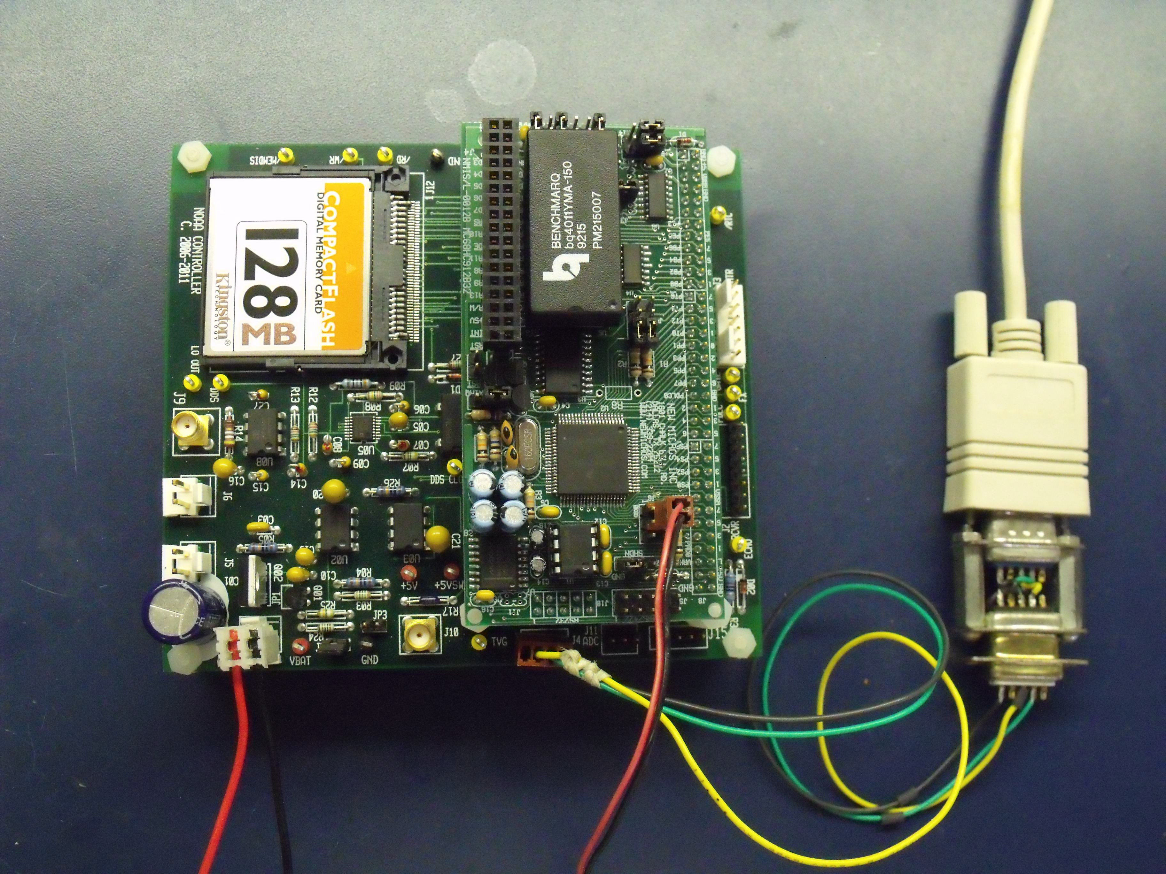

The Controller card setup for testing. A power cable is attached to J1 and a made-up serial cable to J4. Note the use of an adaptor to the null-modem cable running to the computer. Use of a straight cable would eliminate the need for the adaptor (as would re-wiring the DB-9 connector). A small pushbutton is connected to the red and black wires running to the SBC. This is used to induce hardware resets.

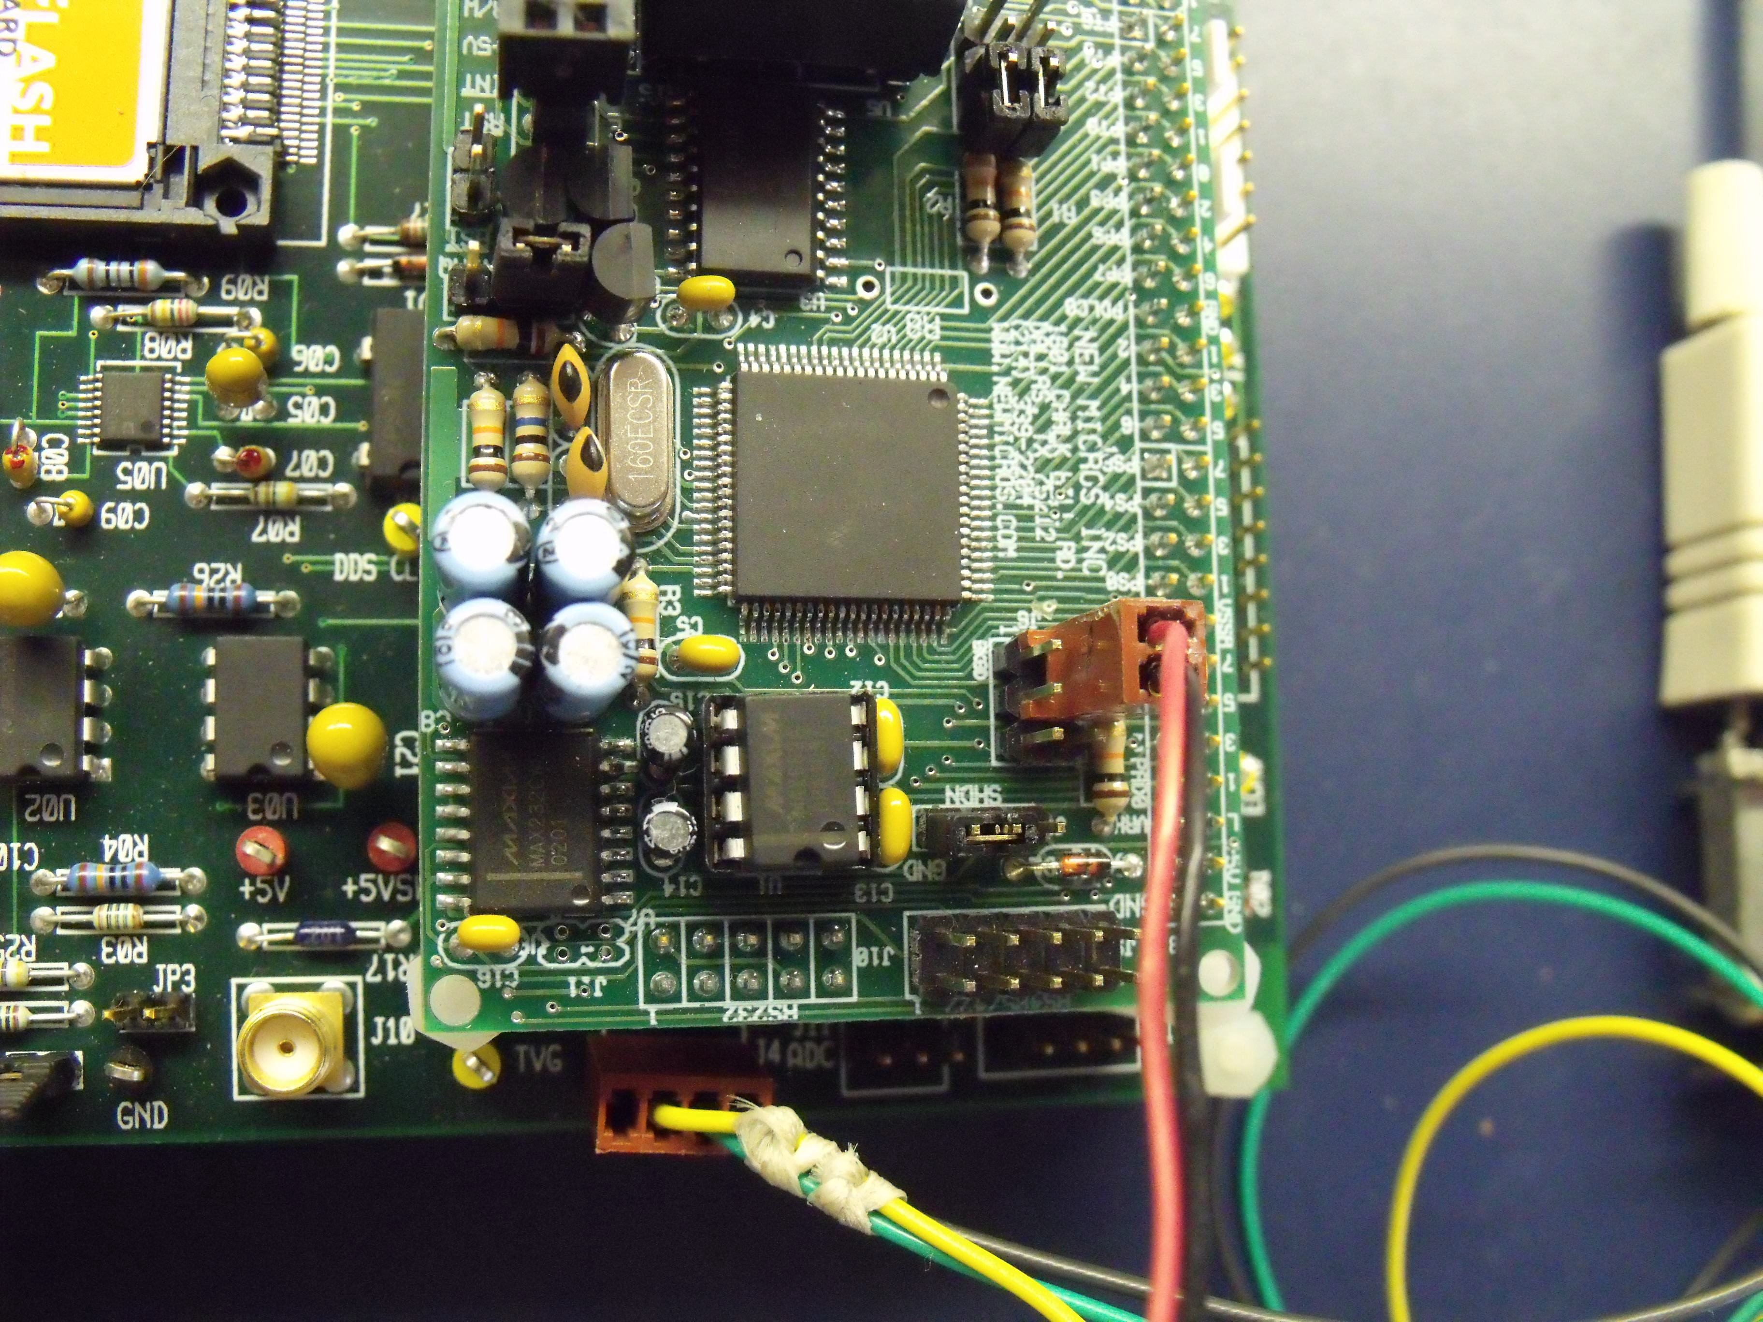

A close-up showing the reset pins. Shorting these two pins causes a hardware reset of the CPU.

